- May's Monetary Policy Committee meeting saw the Bank of England send a clear message that a summer rate cut is likely. Whether the first cut comes in June or August remains finely balanced and will be heavily affected by the April data for pay growth and services inflation.
- A big upside surprise for UK GDP growth in Q1 added to the evidence that the economy is on the road to recovery after two years of stagnation. We will likely revise up our forecast for 2024 GDP growth from an already-above consensus 0.6%.
Since the turn of the year, the Bank of England's Monetary Policy Committee has been inching towards cutting interest rates. But this week saw the committee take its most decisive step yet by clearly signalling that rates were likely to be cut in June or August, provided that the data was supportive.
There were three signals of the MPC's intent. First, Deputy Governor Dave Ramsden joined Swati Dhingra in voting for a 25bps cut, which appeared to be a significant signal of the way that sentiment is changing on the committee. Second, the MPC cut its inflation forecast throughout the forecast horizon (Chart 1). Based on market interest rate expectations, it now expects inflation to drop below target in years two and three, a sign that the MPC expects to cut rates more aggressively than market pricing had implied. And third, the minutes included new language around the timing of the first cut, referring to considering "forthcoming data releases", whereas previously it had not indicated a timeframe. This change suggests a greater urgency, and in his opening remarks at the press conference, Governor Andrew Bailey drew attention to the change, emphasising its significance.
A more dovish attitude was also evident in the MPC judging that, compared with previous inflation projections, a greater proportion of past increases in import prices had already passed through to consumer prices, and that the second-round effects on domestic prices and wages will fade more quickly than previously thought.
Chart 1: The MPC's sub-2% inflation forecast implies market pricing is too high
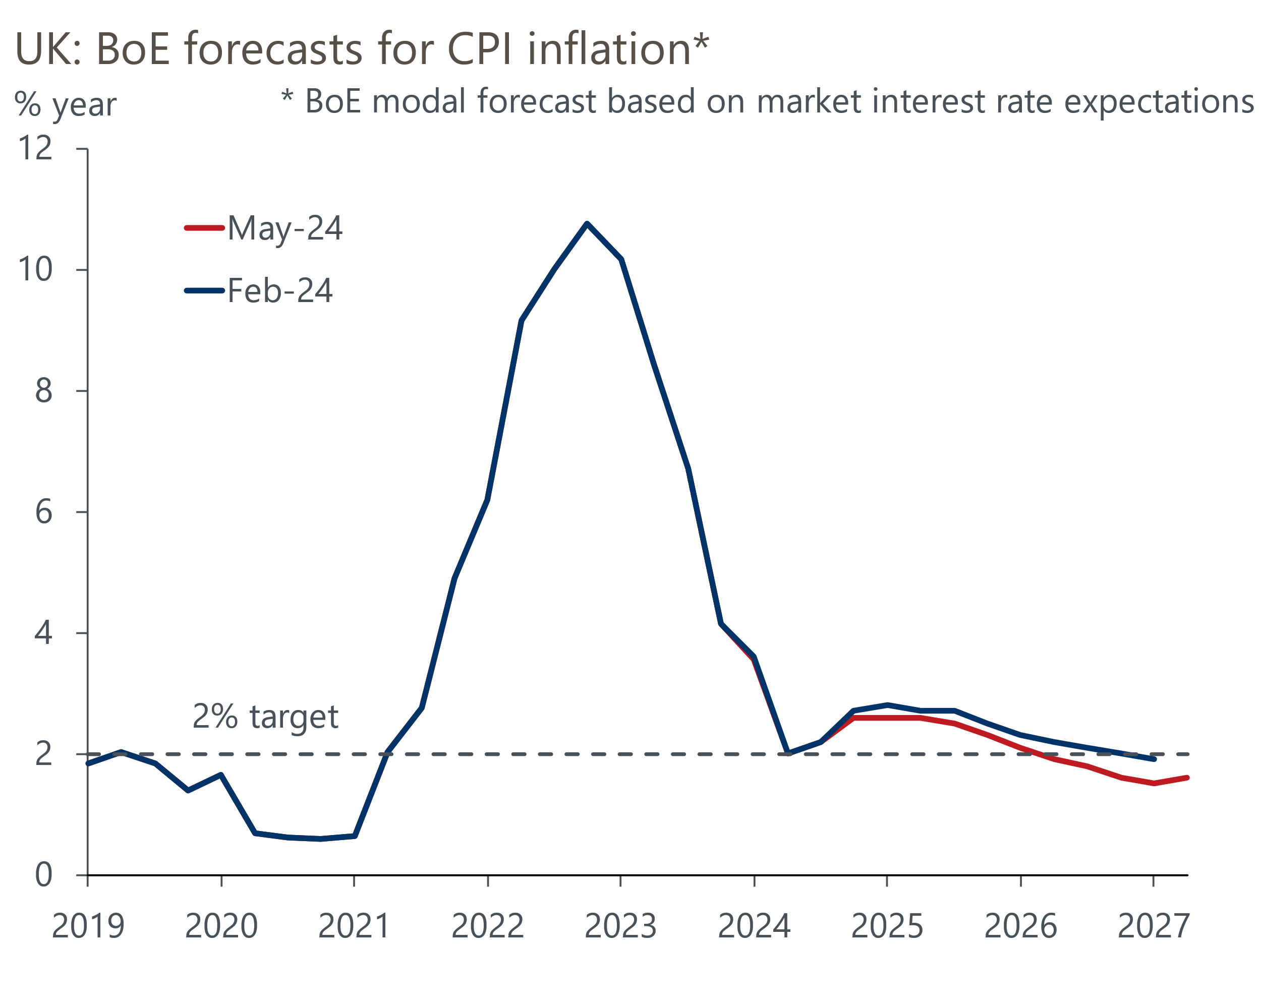
Source: Bank of England Monetary Policy Report

At the press conference, there was further discussion of the idea that policy would still be restrictive even after the MPC had started to cut rates. Bailey also reiterated his views that inflation dynamics are different in the US and UK, and that the Fed's behaviour would not influence the timing of a UK interest rate cut. Overall, the MPC gave a clear indication that it expects to be in a position to cut interest rates very soon. Indeed, data permitting, that move could come as soon as the next meeting in June – Bailey said that a June cut was neither "ruled out" nor "a fait accompli".
We've long argued that the April data for pay and inflation will be key. The pay data will show the impact of the near-10% rise in the national living wage, while the inflation data will show the impact on core inflation of the annual increases for index-linked contracts and regulated prices. The MPC will have all of the relevant data at its June meeting. BoE staff raised their forecasts for the MPC's two key measures of inflation persistence – services inflation and private sector regular pay – compared with February, so the scope for upside surprises to derail a potential rate cut appears to be more limited.
The results of the BoE's April Decision Maker Panel also provided some reassurance that the data will support a rate cut. Despite that month's NLW rise, annual wage growth slowed to 5.9%, from 6.1% in March. Though the fall in the annual growth rate was small, the scale of the NLW rise meant pay growth could have risen. And there's no evidence that the large rise in the NLW is rippling up the pay distribution.
Whether the first cut comes in June or August is finely balanced, and we will revisit our call when the April inflation data is published in a couple of weeks. As things stand, our central forecast remains that the first cut will happen in June. We still expect a total of 75bps of cuts this year, consistent with the BoE's signal that market pricing is too hawkish.
The MPC's new forecast assumed that GDP grew by 0.4% q/q in Q1, in line with our expectations. But that proved too pessimistic, with the Office for National Statistics subsequently reporting growth of 0.6%. The upside surprise was due to a combination of February's rise being revised up to 0.2% from 0.1%, and a bumper 0.4% m/m increase in GDP in March. Unlike previous months, March saw no drag on health output from industrial action, while GDP was also boosted by a strong increase in output in consumer-facing sectors (Chart 2).
Chart 2: A broad-based pickup underpinned a large upside surprise for GDP in March
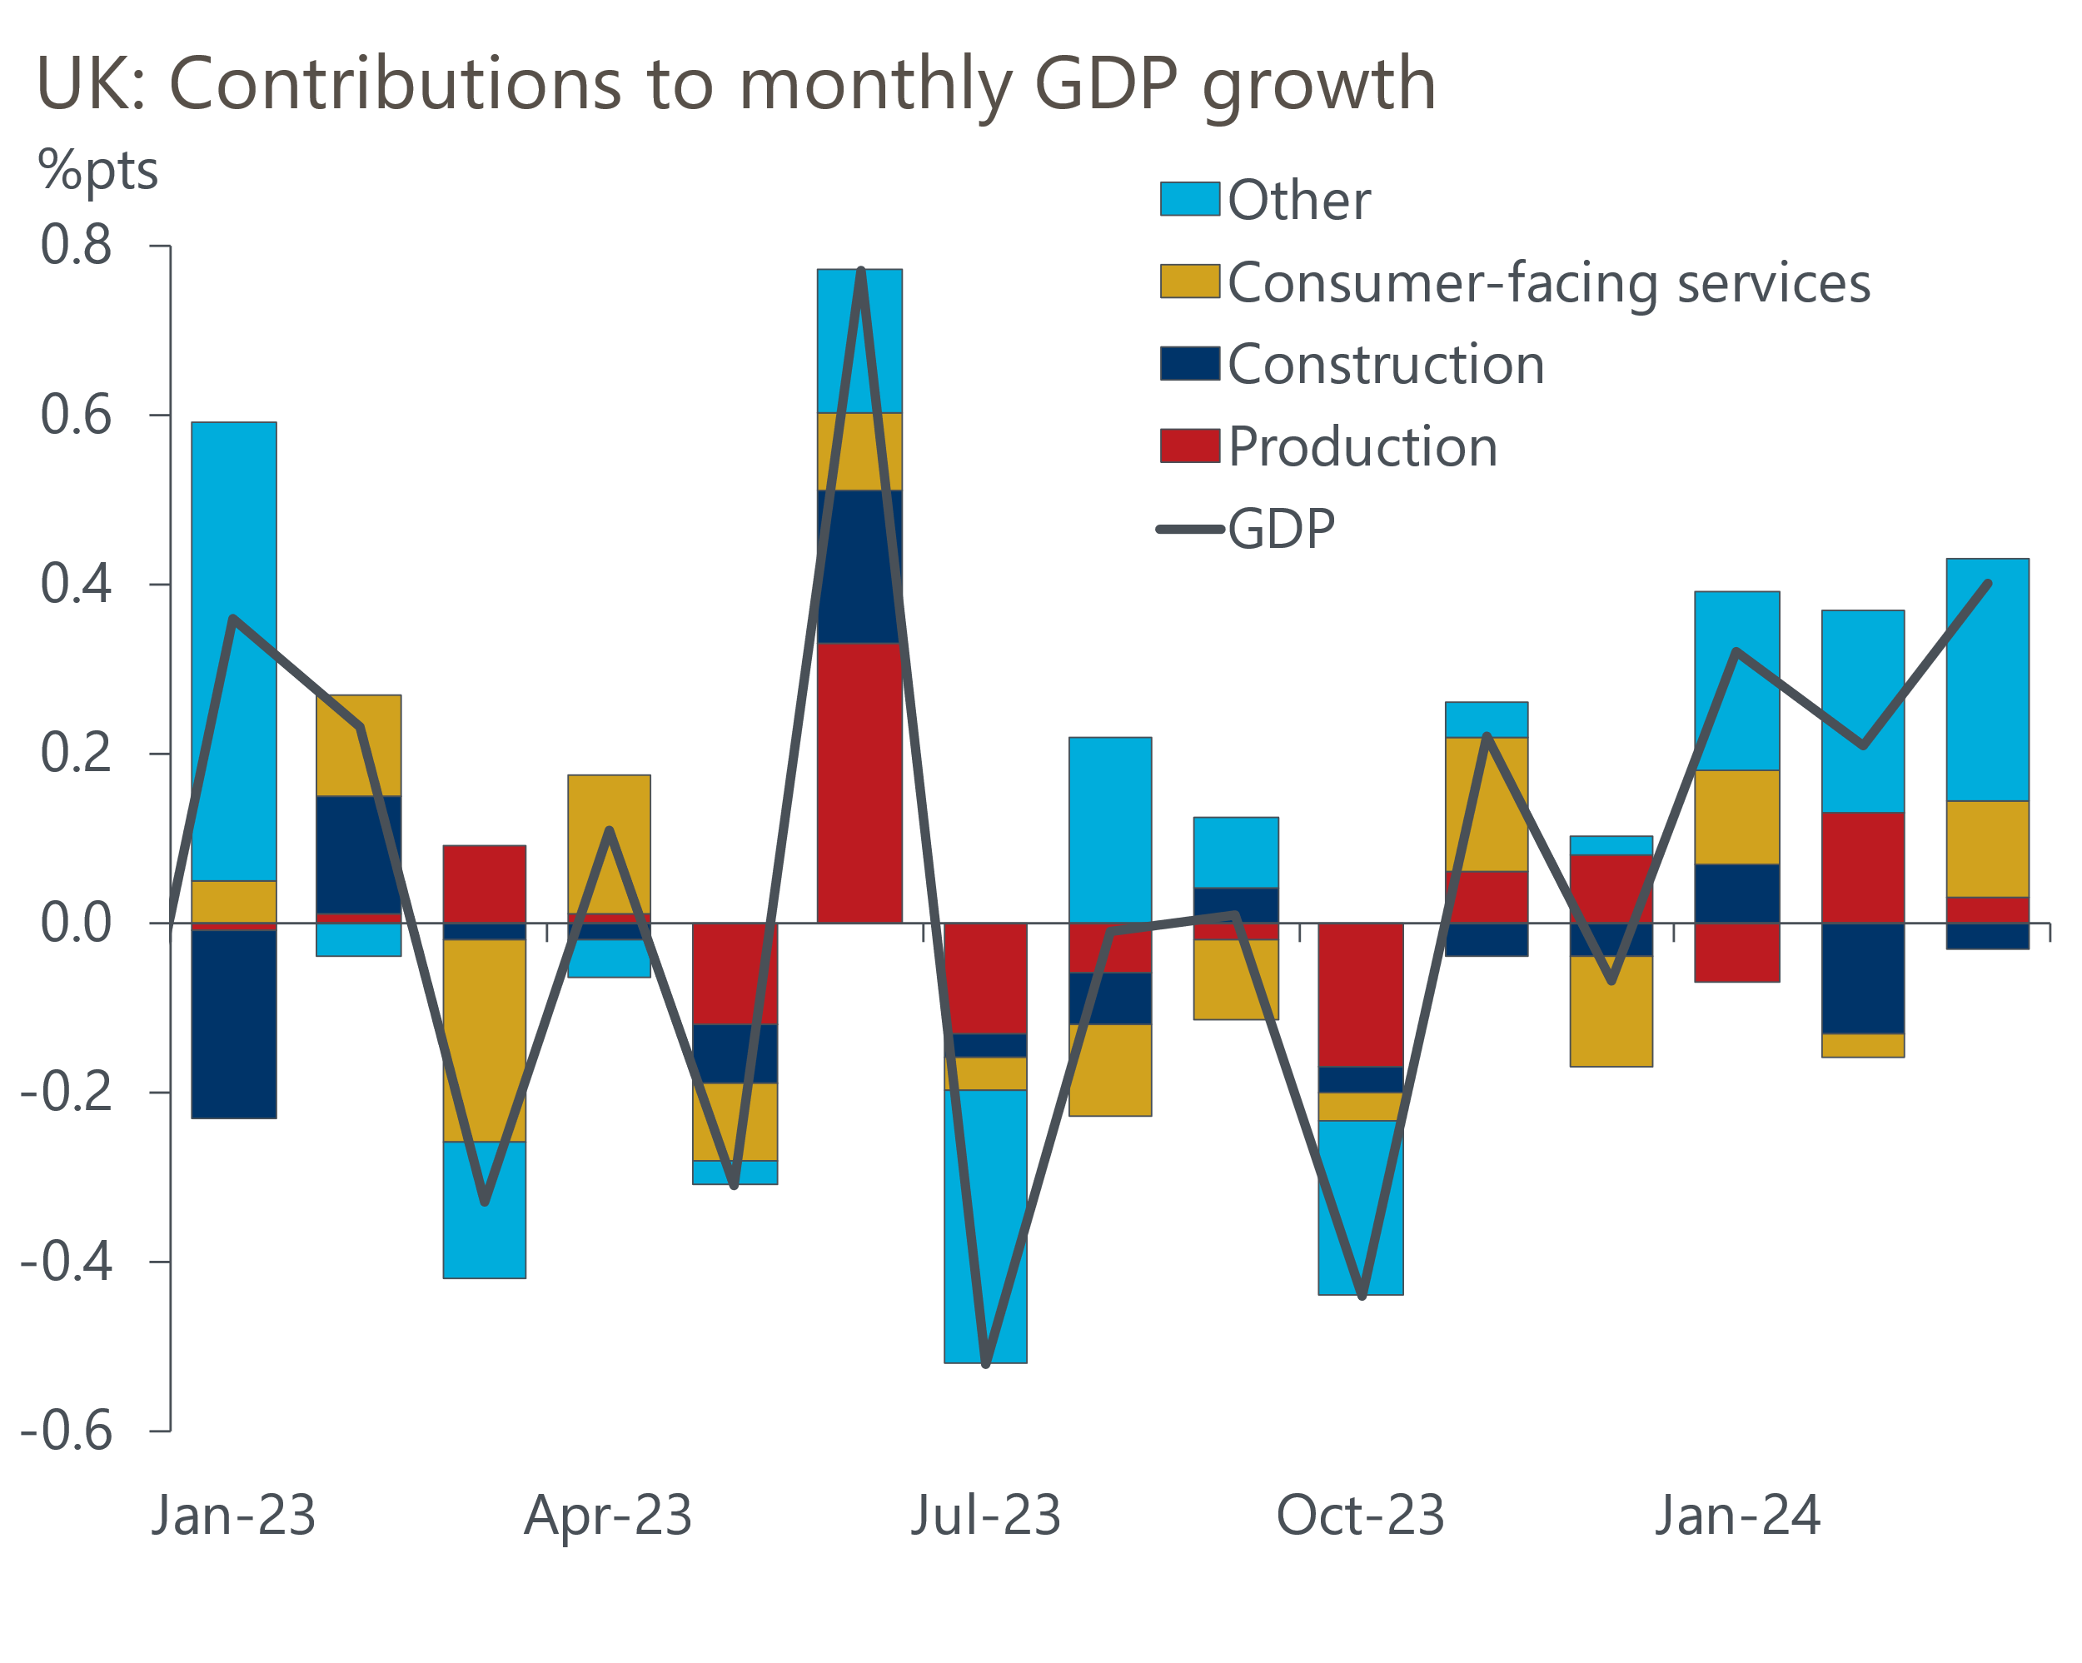
Source: Haver Analytics
We suspect the earlier-than-normal Easter might have been a factor in March's consumer strength, suggesting there could be some payback in April. But conversely, there's scope for a rebound in construction output, given that unusually wet weather hampered activity in the sector in February and March. And given early business survey data for Q2 has been similarly positive, we expect Q1 to mark the beginning of a sustained recovery in economic growth after two years of stagnation. Incorporating the Q1 outturn will likely further increase our 2024 forecast for GDP growth from an already-above consensus 0.6%.

The week ahead
Next week's only major data release is the labour market statistics for January-March. Our focus will be on the pay data, both due to its importance to the MPC and because of February's upside surprise. Timelier indicators from HMRC and the BoE's Decision Maker Panel have suggested that pay growth has continued to cool, while our own sentiment data points to a more severe slowdown. We expect headline total pay growth to cool to 5.3% in March, with regular pay growth at 5.8%.
The Labour Force Survey data remains very volatile, with the ONS still to implement changes that it hopes will increase sample sizes. Other indicators, including HMRC's count of payrolled employees and our own nowcast, suggest labour demand is cooling gently, and we think the ONS will report that unemployment was 4.2% in Q1.
Table 1: Week ahead calendar
Date | Events | Period | Measure | Unit | Previous | Forecast
May 14 | LFS unemployment | Jan-Mar | Rate | % | 4.2 | 4.2
May 14 | Average earnings (total pay) | Mar | 3m, y/y | % | 5.6 | 5.3
May 14 | Average earnings (regular pay) | Mar | 3m, y/y | % | 6.0 | 5.8
Source: Oxford Economics

Key forecasts
Table 2: UK forecast overview
(Annual percentage changes unless specified)
 | 2022 | 2023 | 2024 | 2025 | 2026 | 2027
GDP | 4.3 | 0.1 | 0.6 | 2.0 | 2.0 | 1.6
Private consumption | 4.8 | 0.2 | 1.0 | 2.6 | 2.2 | 1.6
Fixed investment | 8.0 | 2.2 | -2.8 | 1.1 | 2.8 | 2.1
Government consumption | 2.3 | 0.5 | 4.1 | 2.2 | 1.5 | 1.5
Exports of goods and services | 9.0 | -0.5 | -0.8 | 2.8 | 2.4 | 1.7
Imports of goods and services | 14.6 | -1.5 | 1.5 | 3.9 | 2.9 | 1.9
Industrial Production | -3.5 | -0.3 | 0.1 | 0.9 | 1.5 | 1.2
Consumer prices | 9.1 | 7.3 | 2.3 | 2.2 | 2.3 | 2.2
Unemployment rate (%) | 3.9 | 4.0 | 4.2 | 4.0 | 3.8 | 3.8
Current a/c balance (% of GDP) | -3.1 | -3.3 | -2.9 | -3.0 | -3.0 | -3.0
Government balance (% of GDP) | 4.4 | 5.0 | 3.6 | 3.1 | 2.3 | 1.5
Cen. bank policy rate (%, EOP) | 3.50 | 5.25 | 4.50 | 3.50 | 2.50 | 2.00
10yr govt. bond yield (%, EOP) | 3.67 | 3.54 | 3.90 | 3.51 | 3.02 | 2.85
Exchange rate (US$ per £, EOP) | 1.20 | 1.27 | 1.26 | 1.27 | 1.30 | 1.32
Exchange rate (euro per £, EOP) | 1.13 | 1.15 | 1.17 | 1.17 | 1.17 | 1.16
Source: Oxford Economics
Table 3: Quarterly forecasts for the UK
 | 2024 |  |  |  | 2025
 | Q1 | Q2 | Q3 | Q4 | Q1 | Q2 | Q3 | Q4
GDP (% year) | 0.0 | 0.2 | 0.7 | 1.6 | 1.7 | 2.0 | 2.1 | 2.2
CPI inflation (% year) | 3.5 | 1.9 | 1.8 | 2.1 | 2.0 | 2.0 | 2.3 | 2.3
Bank Rate (%, EOP) | 5.25 | 5.00 | 4.75 | 4.50 | 4.25 | 4.00 | 3.75 | 3.50
10yr gilt yield (%, EOP) | 3.95 | 4.10 | 3.97 | 3.90 | 3.81 | 3.72 | 3.62 | 3.51
US$ per £ (EOP) | 1.26 | 1.25 | 1.25 | 1.26 | 1.26 | 1.26 | 1.27 | 1.27
Euro per £ (EOP) | 1.17 | 1.17 | 1.17 | 1.17 | 1.17 | 1.17 | 1.17 | 1.17
Source: Oxford Economics

Latest Country Economic Forecast:
April 22, 2024

Recent publications

Data Insights
Strong March delivers a big upside surprise for GDP in Q1
April's services PMI suggests Q2 started on a strong footing
April's PMI pointed to a renewed fall in manufacturing activity
Higher interest rates temper recovery in mortgage demand
Flash PMIs suggest economic recovery is gaining momentum

Research Briefings
How quickly are indirect effects on core inflation fading?
Dovish MPC signals a summer rate cut is likely
MPC preview – Edging closer to rate cuts
Nowcast shows wage growth slowing sharply
What the Bernanke review says about the state of forecasting

Contacts

Oxford Economics' UK team
- Andrew Goodwin - Chief UK Economist - agoodwin@oxfordeconomics.com
- Edward Allenby - UK Economist - eallenby@oxfordeconomics.com

